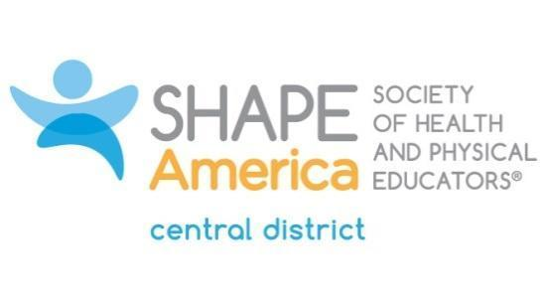

Central District Scholar Award

Criteria:
Criteria used in the selection of the District Scholar shall include but not be limited to the following:
- The individual selected should have a scholarly/creative record as evidenced by grant activities, referred publications and scholarly/artistic presentations.
- The individual should be an active scholar/creative artist in his/her discipline.
- The individual selected should provide evidence of in-depth study in a specific area of SHAPE America/District concern.
- The individual selected must be a member of SHAPE America.
- The individual selected should be capable of communicating to groups in the various disciplines
- The individual selected must agree to present his/her work in at least one presentation the following year after receiving the award.

Nomination Format:
- Sponsor’s Statement (importance of scholarly work) (1/2 page)
- Personal Data (1/4 page)
- Education (1/4 page)
- Professional Experience (1/2 page)
- Honors (international, national, state, etc.) (1/2 page)
- Publications (provide a summary before listing under separate categories: (I) books or monographs; (II) refereed articles; (III) abstracts; (IV) chapters in books, etc.; (V) non-refereed articles (maximum limit of six (6) pages)
- Creative Activities (choreography, dance presentations, literary works, artistic media productions, etc.) (to be included in f. above)
- Invited Presentations (limit to the fifteen most important and summarize as to level – e.g. “national” (maximum of one (1) page)
- Professional Organizations and Activities (indicate membership, offices held, and years of service (maximum of one (1) page)

NOTE: The entire submission should not exceed ten (10) pages.

Send all nominations to:
Jennifer Peterson
jennifer.peterson@wmpenn.edu
Nominations Due: October 15

